**10 Common Challenges in Project Management (and How to Solve Them)**

[[ Sandeep Kashyap](https://www.proofhub.com/author/sandeepkashyap)Sandeep Kashyap](https://www.proofhub.com/author/sandeepkashyap)

August 6, 2019

[Articles](https://www.proofhub.com/articles), [Work and Project Management](https://www.proofhub.com/articles/work)



share

Managing projects is hard work. We hear a lot about the project management challenges that project managers commonly face. Here I have created a list of project challenges that become a reason for project failure. Let’s have a look.

**Table of Contents**[[show](https://www.proofhub.com/articles/project-management-challenges)]

**What Are the Challenges of Project Management?**

1. Keeping Teams on The Same Page
2. Poorly Defining the Goals And Objectives
3. Unrealistic Deadlines
4. Finding The Right Project Management Software
5. Scope Creep is Insidious And Creepy
6. Insufficient Team Skills
7. Miscommunication Cause Conflicts
8. Risk Management
9. Challenges of Teamwork
10. Lack of Accountability

As I started ProofHub and began to grow, I have worked with and hired a great number of project managers. Throughout the years, I have noticed the many challenges project managers are facing in project management.

The right mix of planning, controlling, and monitoring can make a difference in [how project managers complete the project](https://www.proofhub.com/articles/how-to-manage-a-project) on time, on budget, and with high-quality results.

A project manager is supposed to be a leader, not only for the project, but also for the team. Only 2.5 percent of companies successfully complete their projects. Aren’t the numbers staggeringly disappointing? They are, for sure.

Managing projects is no less than running a small city. You have to take care of the projects, resources, deadlines, manage the budget, ensure proper communication, foresee potential risks and what not.

Taking care of so many things can be nerve-wracking and it’s not surprising if something slips out of your mind. Every day we hear the same stories, common challenges and issues in project management. Yet we fail to learn our lesson out of those stories.

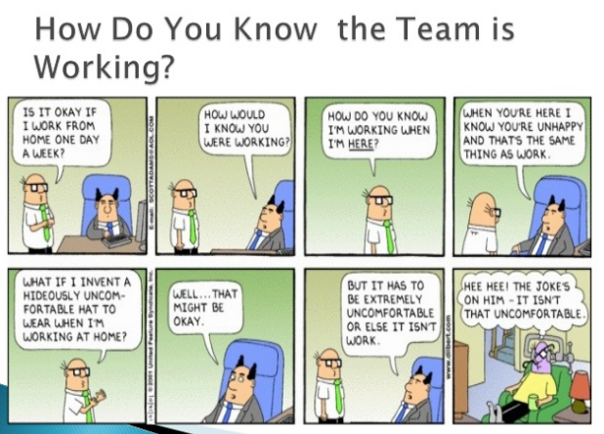

Source: https://image.slidesharecdn.com/leadingvirtualteamsin2012resources-130204210338-phpapp02/95/leading-virtual-teams-in-2012resources-14-638.jpg?cb=1360012144

Being a project manager, have you ever wondered why only a handful of companies manage to [deliver projects successfully](https://www.proofhub.com/articles/how-to-plan-a-project) whereas you struggle to even meet the deadlines?

It’s because besides having the ability to plan, [manage resources](https://www.proofhub.com/articles/the-definitive-guide-to-resource-management), and meet deadlines, one must possess the ability to foresee the challenges that may hamper the progress of the overall project.

A solution to all your project management troubles!

[**Try ProofHub**](https://www.proofhub.com/try/?utm_source=ProofHub.com%2FArticles&utm_medium=Referral&utm_campaign=Project%20management&utm_term=CTA&utm_content=Project%20management%20challenges)



How do you identify project challenges? As a part of today’s article, we have researched the typical challenges a project manager can expect to meet while a project is in motion. Let’s see what these challenges are:

**Challenge #1: Keeping Teams on The Same Page**

Managing a team that is widely spread out is one big challenge for project managers. Keeping your team on the same page will make things happen interactively. Each team member will know exactly what’s going on, what they need to do, and what each of them is working towards.

We have a growing team at **[ProofHub](https://www.proofhub.com/)**, but it has never been a challenge for me to keep track of teams on the same page and ensure no missing tasks, because we have everything under control with ProofHub.

***Solution:****Here’s a breakdown of how ProofHub can help and how many teams are using this tool:*

* Bring all your team and client conversations about a specific task on a single page to avoid digging through long email threads.
* Every project includes a schedule and a team working for that project. Stay on top of your schedule and know what’s coming up with calendar views.
* Know who works on what part and get notified of tasks moving from one stage to another, keeping everyone together.

Now you can ditch Trello, JIRA, Asana or other messy tools and have a simplified [team management](https://www.proofhub.com/articles/managers-guide-to-team-management) around ProofHub. It’s all you need.

*Recommended reading:*

* [Top 17 Trello Alternatives: List of Project Management & Kanban Software](https://www.proofhub.com/articles/trello-alternatives)
* [21 Best Jira- Alternatives for Agile Project Management in 2019](https://www.proofhub.com/articles/jira-alternatives)
* [11 Powerful Asana Alternatives for Project Management in 2019](https://www.proofhub.com/articles/asana-alternatives)
* [Top 38 Basecamp Alternatives for Project Management](https://www.proofhub.com/articles/basecamp-alternatives)

**Challenge #2: Poorly Defining the Goals And Objectives**

Poorly defined goals or goals without objectives pushes a project in danger. An important step in a project is to define goals and objectives—and that becomes a major challenge.

The project managers and team members might not be knowing what exactly to expect from the project. If the goals and objectives are not clearly defined, the project is doomed to fail. When no one is aware of the whats, whys and whens of the project, what will follow is a lot of confusion and chaos.

Starting a project without [**clear objectives**](https://www.proofhub.com/articles/smart-goal-setting-examples-for-project-managers), a specific direction and a [**prepared plan**](https://www.proofhub.com/articles/how-to-plan-a-project); it’s like going on a road trip with no idea where you’re going and how to get there. You will waste gas, time and effort. Likewise, your business suffers when there is no clarity and forethought before starting a project.

***Solution****: Setting a goal is inclined towards developing  a proposal and then defining objectives that would help to achieve the goal. When you know your goals, you can define the objectives that is the how, why, and what you need to do for project planning. This is why it’s recommended to hold a kickoff meeting and use*[*project planning software*](https://www.proofhub.com/how-it-works/project-planning-software)*to define clear goals.*

***Hey, have you tried ProofHub lately?***[***Try it for free***](https://www.proofhub.com/try?utm_source=ProofHub.com%2Farticle&utm_medium=Referral&utm_campaign=Project%20management&utm_term=CTA&utm_content=Project%20management%20challenges)***!***

**Challenge #3: Unrealistic Deadlines**



Do you always impose a deadline on your project members that they possibly can not meet? A big thing that most teams or project managers struggle is unrealistic to project deadlines and expectations clients and stakeholders have from them. Most [project timelines](https://www.proofhub.com/articles/timeline-project-management) do eventually slip due to the unrealistic ‘initial deadlines’. As we live in a world, where competition is getting aggressive and targets are set either unrealistic or unachievable rather than driven by calculated business requirements. From then, what begins is a desperate attempt where the team tries to fit the requirements in the already drawn boundaries.

***Solution****: First, talk about the concerns with your client or manager and look if there are any unknown factors that drive the project deadline. Although it may seem that the deadlines are foolishly imposed that you can’t meet, that surely needs a quick look over.*

Project managers can take care of the project deadlines and other related issues with impeccable planning, alternative analysis and [**proper communication**](https://www.proofhub.com/articles/effective-team-communication) of the real-time progress to project participants and other key decision-makers. Plan your events, manage your schedule, and keep track of important dates with a project calendar.

**Challenge #4: Finding The Right Project Management Software**



It can be tedious to identify the right technology for your project team that is within your budget, to implement your projects. A well-designed [project management software](https://www.proofhub.com/project-management-software) will ensure that projects are progressing as planned and allow you to get visibility into all your projects. At times, it can be difficult to find such a tool, especially those that meet your needs.

***Solution:****We know finding the right software is important but this leaves us with a very important question, “Which software is right for my team?”*

**How ProofHub Ends Your Project Management Challenges**

ProofHub is a feature-rich, versatile, and collaborative tool for your teams. Don’t believe us, take a word from others. ProofHub was recently named in [Top 10 Best Project Management Software](https://blog.proofhub.com/proofhub-on-the-list-of-top-10-best-project-management-software-in-2019-6de833bbae6f)

Whether you’re a manager or team member, it has all the features to make sure you complete projects with ease. Let’s take a look at them:

**Planning:**It simplifies the planning process by bringing teams together and getting them brainstorm over ideas faster.

**Tools for planning in ProofHub:**Gantt charts, Custom roles, Task management, Workflows and Kanban boards, Calendar.

**Collaboration:**ProofHub gives agility to distributed team members to come together and achieve great things at work.

**Tools for collaboration in ProofHub:**Group chat, Online discussions, Notes, Email-in, @mentions.

**Organization:**Keep your files, documents, images, PDFs and other important information together and save yourself from the hassle of scattered information.

**Tools for the organization in ProofHub:**Folders, Notes, Quickies, Calendar, Advanced search third-party integration with Google Drive, OneDrive, Box and DropBox.

**Feedback:**Makes the review and approval process quick and easy.

**Tools for online proofing in ProofHub:**Markup tools to highlight sections and mark annotations on files.

**Deliver:** Lets you allocate and manage resources efficiently to deliver projects on time and within budget.

**Tools to deliver projects in ProofHub:**Timesheets, Multiple timers, [Workflows and Kanban boards](https://help.proofhub.com/plus/tasks/manage-workflows/), Custom Reports.

**Challenge #5: Scope Creep is Insidious And Creepy**



Scope creep arises naturally and it becomes a challenge – sneaking up suddenly and hitting your project. For example, at times when the project takes a different shape because the client wants more functionality for the same price and this is the fear of every project manager. Many clients don’t know how to define their project needs, and “I’ll know it when I see it” is tough to meet. This can put project managers and team members in a difficult spot as unpredictable or new changes can often lead to the project failure. Remember, a lot of little changes are as bad as one big change.

***Solution****: If you are a project manager you know that avoid scope creep will definitely increase the chance of delivering the project on time and budget.*

* Make a clear schedule to outline every step of the project.
* Make sure that everyone is on the same page about the requirements.
* Determine project goals (cost, schedule, quality) through a systematic process with [**proper planning**](https://www.proofhub.com/articles/manage-projects-2018-proofhub) and understanding of the customer needs.
* Make realistic assumptions about resource availability and deadlines to achieve quality results. As, there is no 100% anti-scope-creep solution but documenting what is happening and communicating challenges to stakeholders, team, and management in advance might help.
* Use Gantt charts for better project planning and tracking and stay on top of project plans. [Click here to know more about Gantt charts](https://www.proofhub.com/features/gantt-chart-software).

**Challenge #6: Insufficient Team Skills**

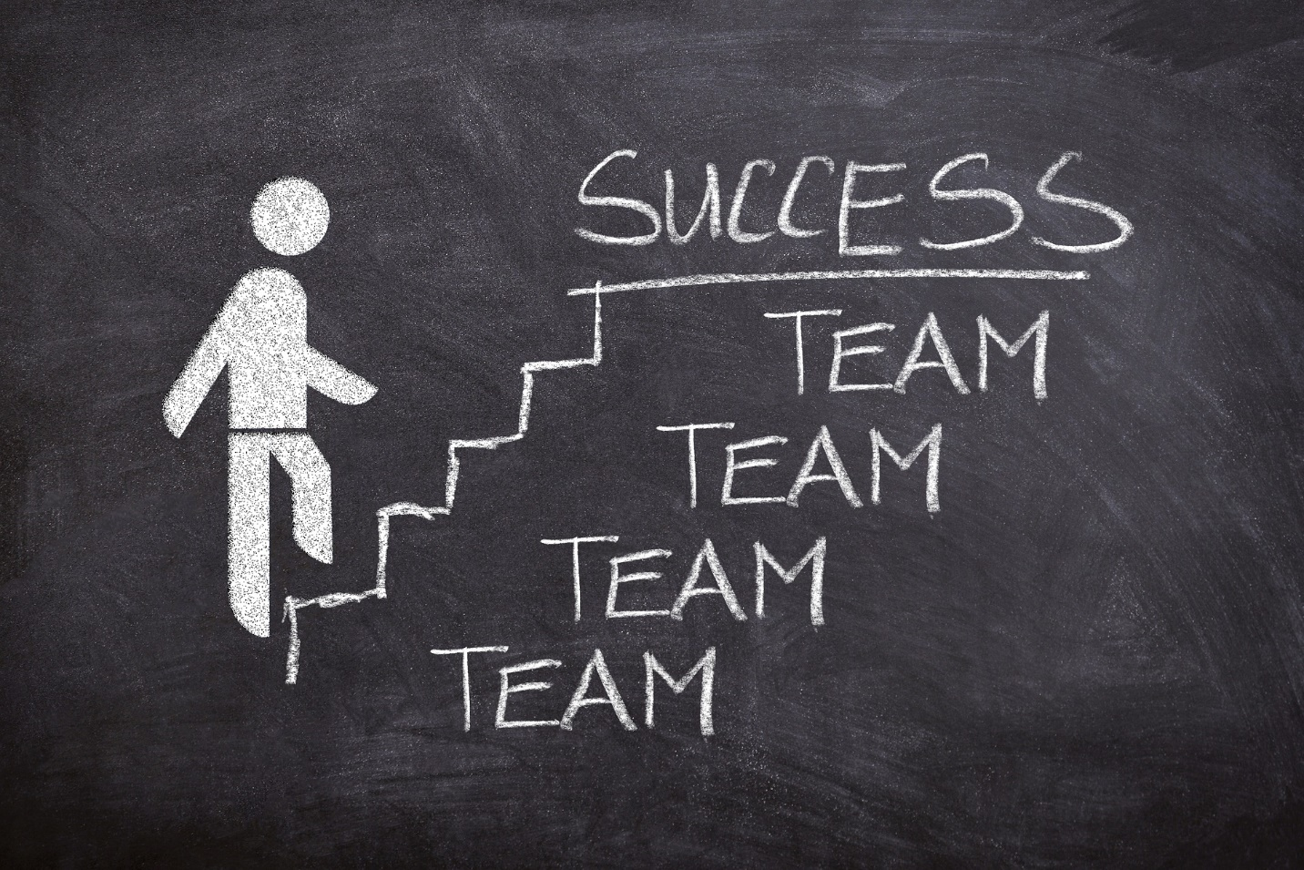

A team is as good as its team members. If team members are not smart or are not trained enough to perform assigned tasks, it can put the development in a risky spot. But most of the times, the team members are assigned on their availability, not for their expertise for many projects. If team members are not skilled or trained enough to meet the challenges and perform [**assigned tasks**,](https://www.proofhub.com/articles/what-is-work-management) it can put the development of the project in a risky spot.

Some projects are challenging or demand a certain level of knowledge and expertise, so it is up to project managers to decide whether team members need to be trained or to add someone with the required skills. Besides this, qualities like the lack of accountability, blaming each other, and finger-pointing can also halt a project.

***Solution****: Document the core set of skills needed to accomplish the workload and analyze the strengths and weaknesses of the team members. If required, train them to enhance their knowledge and end the skill gaps.*

***“Constantly missing deadlines?***[***Sign up now for PoofHub free trial.***](https://www.proofhub.com/try/?utm_source=ProofHub.com%2FArticles&utm_medium=Referral&utm_campaign=Project%20management&utm_term=CTA&utm_content=Project%20management%20challenges)***”***

**Challenge #7: Miscommunication Cause Conflicts**



How many times have you heard of communication issues as an excuse or explanation to unfinished tasks, projects don’t meet deadlines, conflicts or not working together? Miscommunication, poor communication,  is one of the biggest project management challenges that get in the way to [**deliver projects successfully**](https://www.proofhub.com/articles/how-to-plan-a-project).

Communication skills are the project manager’s greatest asset. No matter if you are giving instructions, asking questions or seeking information, there’s always a challenge to provide clear and open communication.

There’s a reason why project managers emphasize a lot on effective communication. Because, most often, successful communication translates into successful projects as 57 percent of projects fail due to breakdown in communications.

***Solution****: Determine proper communication flows for project members and develop a way to inform what information needs to be informed to project members. You can also use*[***collaboration software***](https://www.proofhub.com/articles/best-collaboration-software-2018)*such as ProofHub to ensure that project members are in the loop of the recent developments in the project.*

ProofHub makes it simple and quick to find any document that has been uploaded anytime in the past. Furthermore, you can take care of your communication by having conversations on the same page.

**Challenge #8: Risk Management**



According to Wikipedia, “Risk management is the identification, assessment, and prioritization of risks followed by coordinated application of resources to minimize, monitor and control the events.”

Oftentimes, projects don’t go as planned so risk management is one of the major project management issues that project managers have to deal with. Management experts can tell how seasoned a project manager is with his ability to oversee risks that might creep up in a project anytime. These risks can be an uncertainty in the financial market, hidden flaws in the project plan or unknown factors that can impact the success of a project.

***Solution****: Although it’s impossible to predict every potential risk but with*[***strategic planning and collecting information***](https://www.proofhub.com/articles/how-to-plan-a-project)*beforehand, project managers can anticipate which part of the project is likely to fail. With that information, he can develop control measures that can help them to deal with the risks accordingly.*

***“No more project risks.***[***Try ProofHub for Free now***](https://www.proofhub.com/try?utm_source=ProofHub.com%2Farticle&utm_medium=Referral&utm_campaign=Project%20management&utm_term=CTA&utm_content=Project%20management%20challenges)***.”***

**Challenge #9: Challenges of Teamwork**



In a study published in [The Harvard Business Review](https://hbr.org/2016/01/collaborative-overload), we learn that ‘‘over the past two decades the time spent by managers and employees in collaborative activities has ballooned by 50 percent or more.”

Teamwork isn’t really teamwork unless the team actually works. A team consists of multiple members, each having a different personality, managing and catering to their needs can be a daunting task at times. With so many people working on a project together, there can be disagreements and differences in a team that can have a negative impact on the project and work environment.

Issues and incongruities amongst team members is often a challenge for project managers to deal with. They have to constantly look for ways to take everyone in a team together for the betterment of the project.

***Solution****: The best way to eliminate any issues or negativity in a team is to create a positive work environment. Build trust in the workplace to break down barriers and establish interpersonal relationships.*

**Tip:** Being a project manager, you can also incorporate [some team building activities](https://www.proofhub.com/articles/team-building-activities-for-workplace) to foster a feeling of unison and [teamwork among them](https://blog.proofhub.com/6-impeccable-reasons-why-teamwork-matters-2c1a3a8bf89e).

**Challenge #10: Lack of Accountability**



Everyone wants accountability but a few teams have it. I’m sure we are well aware of the challenge. A project manager has to make sure that the team is accountable throughout their daily workloads. Accountability is visible in the form of blame game when things go wrong but is rarely in the picture when the things are right.

***Solution:****To embrace accountability, make sure you begin it at the start of a project to build it into your workflow. The good news is that effective*[*project management skills*](https://www.proofhub.com/articles/project-management-skills)*can be developed through project management training and skill development.*

In fact, there are many online project management courses and certifications that can do the job for you. Whether you are a college graduate or experienced professional, such courses are helpful in expanding career opportunities and successful project implementation.

If you’re looking out for a tool that offers features like that of [online discussion](https://www.proofhub.com/features/discussions) and [chat](https://www.proofhub.com/features/chat-software), you might end your search [here](https://www.proofhub.com/features/chat-software).

***Tip: ProofHub is a project management tool that supports task visibility and time tracking so the employees are accountable for how they work and what they bring out.***